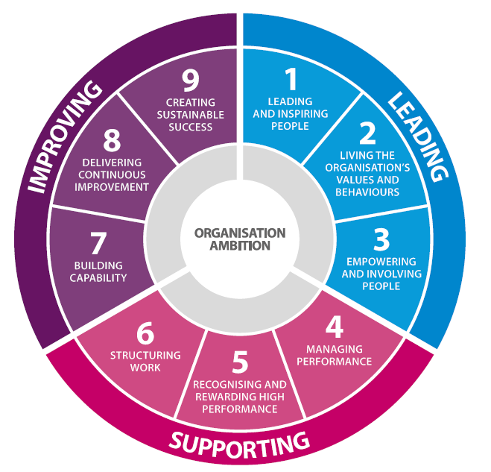
- Leading and inspiring people
Leaders make the organisation’s objectives clear. They inspire and motivate people to deliver against these objectives and are trusted by people in the organisation.

Creating transparency and trust
Motivating people to deliver the organisation’s objectives
Developing leadership capability
- Living the organisation’s values and behaviours

- Empowering and involving people

